Ilsington C of E Primary
PE Curriculum Statement
Our Curriculum statements are designed to be used as a supportive tool to plan teaching and learning across our school. The key skills are derived from the National Curriculum and spilt into individual year groups to support a progressive approach and mixed age classes.

At Ilsington, we believe that Physical Education is an important subject for developing life-long skills which can lead to a healthy active lifestyle within education and beyond. Developing an understanding of physical activity, healthy diet and health and wellbeing is imperative for students of all ages, therefore our PE curriculum has been designed give students regular ( 2 hours/ week) Physical Education to ensure all students are physically active. We continually reinforce the importance of health and wellbeing. The PE curriculum has also been designed to give students access to a wide range of activities over a two-year period, developing the physical skills which are required to play a variety of sports and to maximum opportunity to learn something new. We believe that a positive PE experience at school will allow students to find an activity which they love and subsequently continue to be active beyond education.

Teachers will use their excellent subject knowledge to deliver high quality Physical Education lessons which allow students to develop and implement physical skills, problem solve, analyse performance of themselves and of others, work in teams, compete and strive for personal and team development. Children and class teachers benefit from working alongside professional sports coaches in school each week.

While PE has its own set of skills applicable to different sports and activities, it also contributes to students’ learning by promoting fundamental British Values, supporting their personal development, and improving their physical and mental wellbeing. The learning which takes place within a PE lesson also supports other curriculum subjects such as science (the human body), geography (sporting countries/Olympics), history (history of sport), ICT (video analysis), English (key vocabulary) and maths (scoring and officiating).

Our PE curriculum also allows for holistic development, providing students the opportunity to develop and demonstrate attributes like resilience, dealing with success and failure (winning and losing), sportsmanship, cooperation, teamwork, determination and self-awareness.

In addition to high quality PE lessons, every student will have the opportunity to represent their schools as part of an inter-school festival programme and gain experience of different activities through trips and visits. We also aim to increase participation in sport and physical activity through regular opportunity to attend extracurricular clubs. There are multiple opportunities each week for students to participate to further develop their skills and understanding and to increase their amount of physical activity.

Vocabulary
Children’s command of vocabulary is fundamental to learning and progress across the curriculum. Vocabulary is developed actively, building systematically on pupil’s current knowledge and deepening their understanding of etymology and morphology (word origins and structures) to increase their store of words. Simultaneously, pupils make links between known and new vocabulary, and discuss and apply shades of meaning. In this way, children expand the vocabulary choices that are available to them. It is essential to introduce technical vocabulary which define each curriculum subject.

Vocabulary development is underpinned by an oracy culture and a tiered approach. High value is placed on the conscious, purposeful selection of well-chosen vocabulary and appropriate sentence structure to enrich access to learning and feed into written work across the curriculum.

KS1 Physical Education Vocabulary List
Movement | Fundamental skills | Athletics | Invasion Games | Sport Specific | Net/Wall Games | Striking & Fielding | Other
Run | Underarm | Sprint | Dodge | Jump | Racket | Swing | Win
Skip | Overarm | Long jump | Space | Teamwork | Net | Strike | Draw
Hop | Roll | Javelin | Attacking |  | Swing | Fielding | Loss
Jump | Bounce | Relay | Defending | Sportsmanship | Follow through | Bowling | Heart
Side-step | Score | Hurdles |  | Communication |  |  | Lungs
Crawl | Catch |  |  |  |  |  | Blood
Climb |  |  |  |  |  |  | Muscles
 |  |  |  |  |  |  | Sportsmanship
 |  |  |  |  |  |  | Teamwork

Lower KS2 Physical Education Vocabulary List
All of the above vocabulary, plus words below.
Movement | Fundamental skills | Athletics | Invasion Games | Sport Specific | Net/Wall Games | Striking & Fielding | Other
Side-step | Dribble | Shotput | Chest pass | Jump shot | Forehand | Wicket | Deltoids
Accelerate | Trap | Middle-distance | Bounce pass | Push pass | Backhand | Fielder | Biceps
Decelerate | Scan | Pacing | Shoulder pass | Try | Serve | Stumps | Triceps
 |  |  | Overhead pass | Sandwich catch | Dig | Wicket keeper | Abdominals
 |  |  | Intercept | Tactics | Set |  | Quadriceps
 |  |  | Marking | pivot |  |  | Hamstrings
 |  |  | End zone |  |  |  | Fitness
 |  |  |  |  |  |  | Health

Upper KS2 Physical Education Vocabulary List
All of the above vacabulary, plus the words below
Movement | Fundamental Skills | Athletics | Invasion Games | Sport Specific | Net/Wall Games | Striking & Fielding | Other
Double-movement | Evade | Personal best | Evasion | Lay up | Topspin | Front-foot drive | Flexion
Accelerate | Defensive shape | Discus | Full court press | Push pass | Slice | Wicket Keeper | Extension
Decelerate |  | Down-sweep | Half court press | Flick | Volley | Backstop | Trapezius
 |  | Changeover | Zone defending | Spin pass | Spike | Backing up | Gastrocnemius
 |  |  |  | Arrowhead attack | Trajectory |  | Latissimus Dorsi
 |  |  |  | Jump stop |  |  | Gluteals
 |  |  |  | Pivot |  |  | Protein
 |  |  |  |  |  |  | Carbohydrate
 |  |  |  |  |  |  | Fats
 |  |  |  |  |  |  | Vitamins

At Ilsington each student will receive 2 hours of high-quality PE each week which follow specific learning topics each half term as part of a 2-year rolling programme. Arranging curriculum PE in this way allows students to achieve a depth of understanding of each topic, whilst giving them access to a broad range of different activities within a PE curriculum cycle. As students' progress through the school, they will re-visit activities and access a higher level of learning when re-visiting to ensure there are continually acquiring new knowledge and skills about sport and physical activity.

Our PE lessons also have a focus on life-skills, providing the opportunity for students to develop and demonstrate attributes such as resilience, dealing with success and failure (winning and losing), sportsmanship, cooperation, teamwork, determination and self-awareness.

Teachers identify key knowledge and skill for each topic being delivered, with clear progression apparent through each half term, linked to expected progress for each key stage. This ensures that lessons are relevant and allow for students’ different starting points for a new topic. Consideration is given to how greater depth will be taught, learnt and demonstrated within each lesson, as well as how learners will be supported in line with the school’s commitment to inclusion. Students with coordination difficulties are identified early and receive additional support in the form of a physical movement intervention on a regular basis.

The National Curriculum
Key Stage One:
Pupils are taught to develop fundamental movement skills, becoming increasingly competent and confident through accessing a broad range of opportunities to extend their agility, balance and coordination, individually and with others. They are able to engage in competitive (both against self and against others) and co-operative physical activities, in a range of increasingly challenging situations.

Pupils are taught to:
- Master basic movements including running, jumping, throwing and catching, as well as developing balance, agility and co-ordination, and begin to apply these in a range of activities.
- Participate in team games, developing simple tactics for attacking and defending.
- Perform dances using simple movement patterns.

Key Stage 1 Units:
Basketball, multi-skills, health & fitness, gymnastics, dance, handball, throwing & catching, athletics, rounders, tennis, striking and fielding.

Key Stage 2:
Pupils continue to apply and develop a broader range of skills, learning how to use them in different ways and to link them to make actions and sequences of movement. They should enjoy communicating, collaborating and competing with each other. They should develop an understanding of how to improve in different physical activities and sports and learn how to evaluate and recognise their own success.

Pupils are taught to:
- Use running, jumping, throwing and catching in isolation and in combination.
- Play competitive games, modified where appropriate [for example, badminton, basketball, cricket, football, hockey, netball, rounders and tennis], and apply basic principles suitable for attacking and defending
- Develop flexibility, strength, technique, control and balance [for example, through athletics and gymnastics]
- Perform dances using a range of movement patterns.
- Take part in outdoor and adventurous activity challenges both individually and within a team.
- Compare their performances with previous ones and demonstrate improvement to achieve their personal best.

Key Stage 2 Units:
Basketball, invasion games, health & fitness, gymnastics, multi-skills, dance, handball, throwing & catching, rounders, ultimate frisbee, athletics, tennis, striking and fielding.

Swimming and water safety

We provide swimming instruction in key stage 2 to ensure that pupils can:
- Swim competently, confidently and proficiently over a distance of at least 25 metres.
- Use a range of strokes effectively [for example, front crawl, backstroke and breaststroke]
- Perform safe self-rescue in different water-based situations.

Key skills
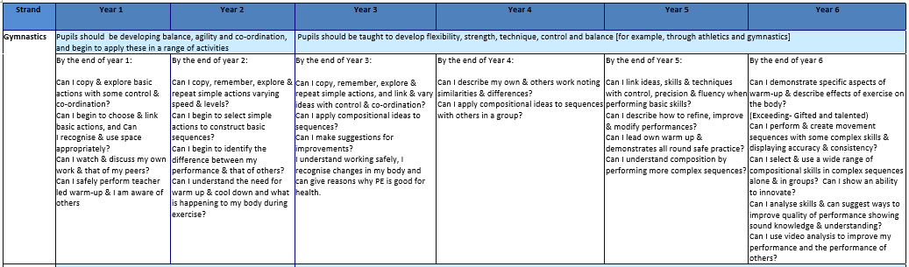
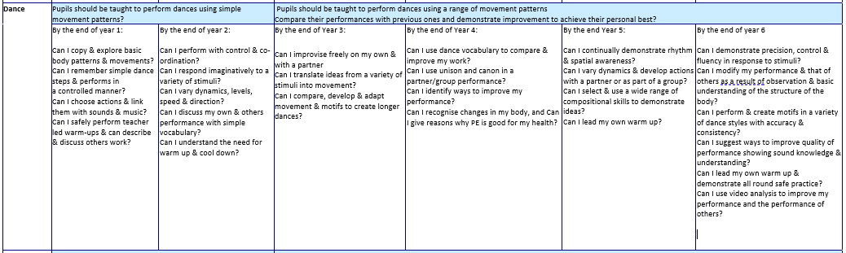
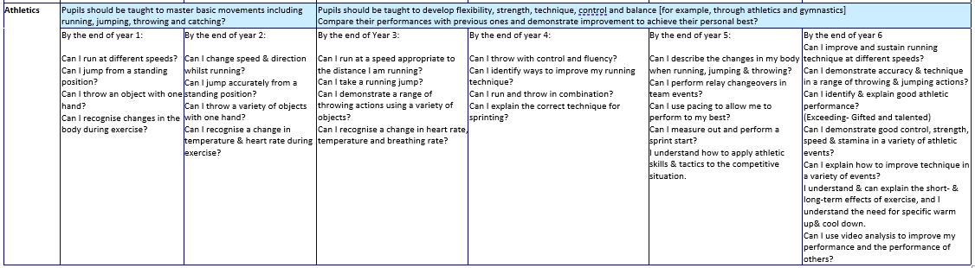
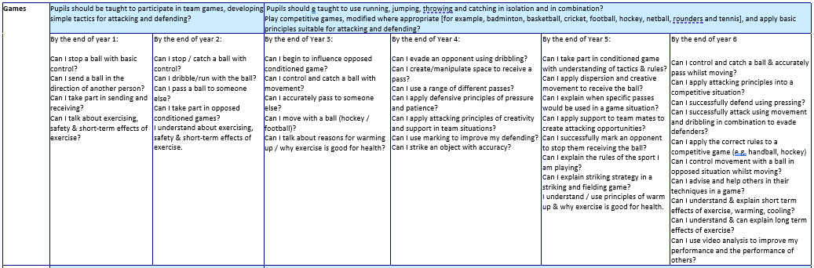
In order to assess impact - a guide
Termly assessment is carried out of fundamental movement and skills, which inform staff of student progress, which subsequently informs future teaching of the subject. The assessment areas have been selected to represent key physical skills which are applicable to a variety of physical activities and each topic taught has the opportunity for students to demonstrate their development of the fundamental skills. The assessment areas are as follows:

Object control
- Throwing
- Catching
- Striking

Body control/movement
- Balance
- Flight
- Travel

Assessment sheet shown below:

