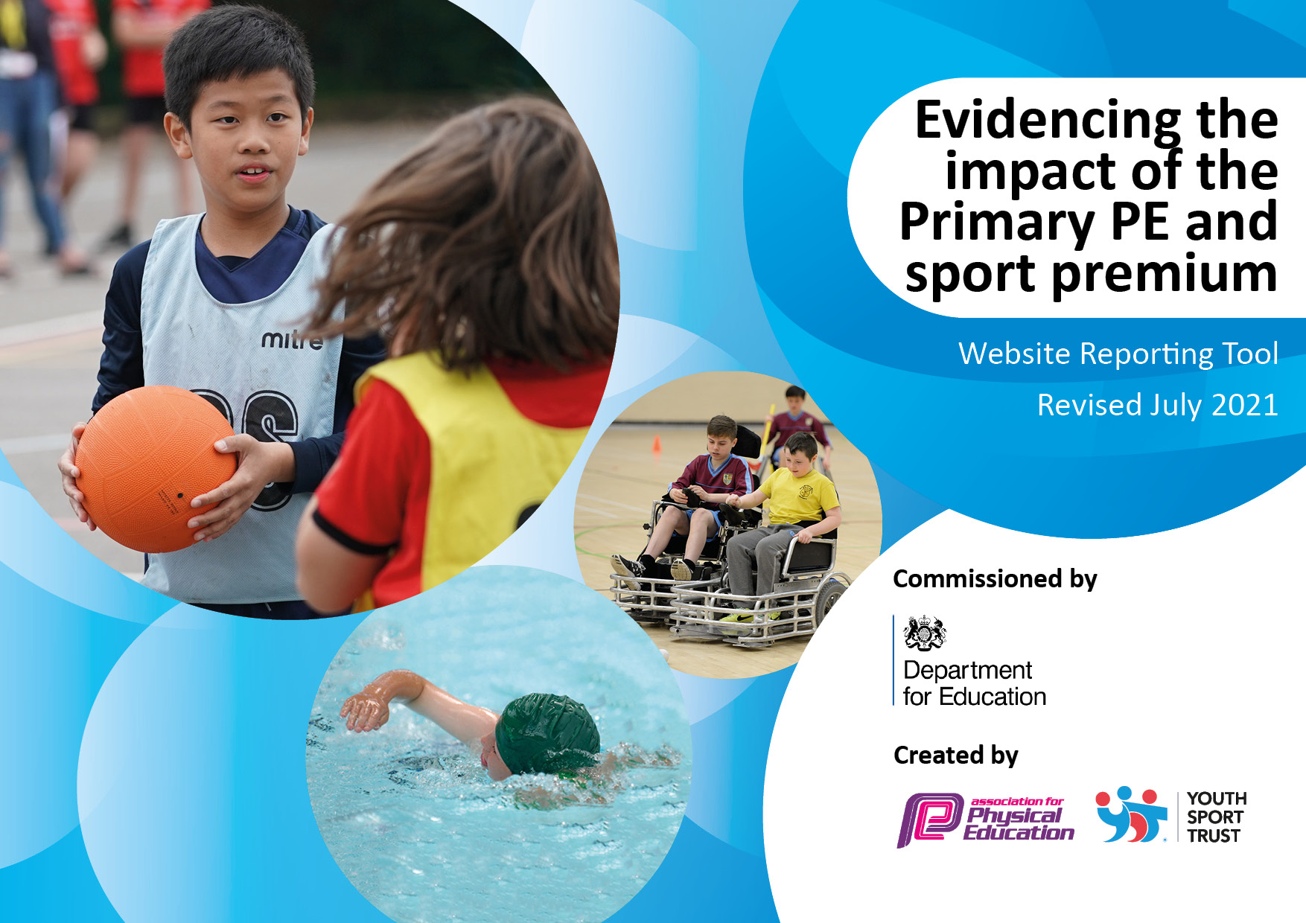
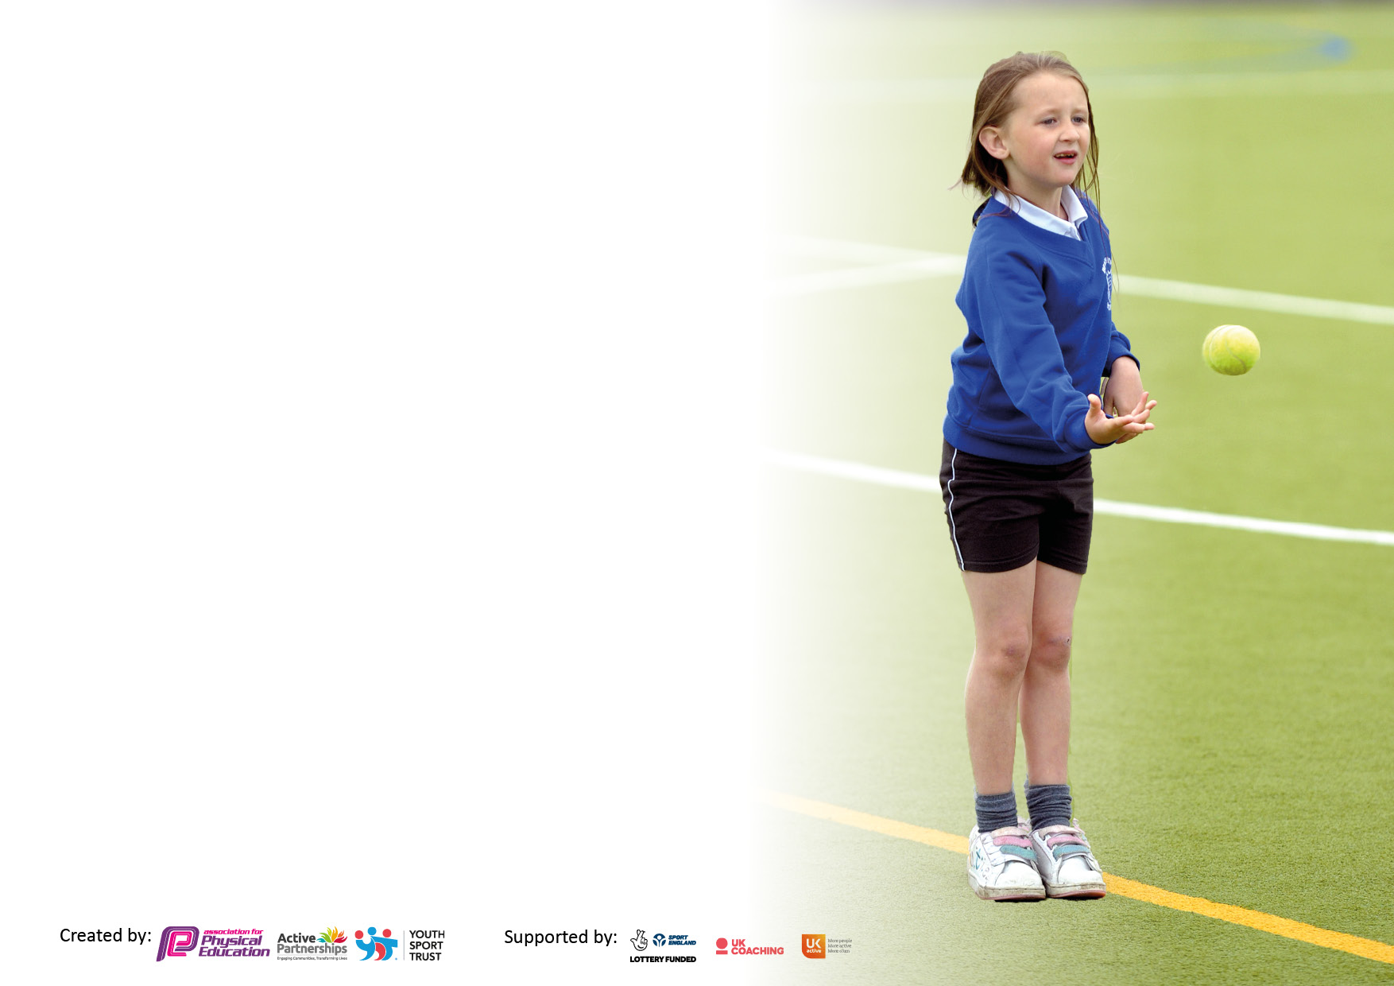

It is important that your grant is used effectively and based on school need. The Education Inspection Framework makes clear there will be a focus on ‘whether leaders and those responsible for governors all understand their respective roles and perform these in a way that enhances the effectiveness of the school’.

Under the Quality of Education Ofsted inspectors consider:
Intent - Curriculum design, coverage and appropriateness
Implementation - Curriculum delivery, Teaching (pedagogy) and Assessment
Impact - Attainment and progress

To assist schools with common transferable language this template has been developed to utilise the same three headings which should make your plans easily transferable between working documents.

Schools must use the funding to make additional and sustainable improvements to the quality of Physical Education, School Sport and Physical Activity (PESSPA) they offer. This means that you should use the Primary PE and sport premium to:

- Develop or add to the PESSPA activities that your school already offer
- Build capacity and capability within the school to ensure that improvements made now will benefit pupils joining the school in future years
- The Primary PE and sport premium should not be used to fund capital spend projects; the school’s budget should fund these.

Pleasevisitgov.ukfortherevisedDfEguidanceincludingthe5keyindicatorsacrosswhichschoolsshoulddemonstrate animprovement.Thisdocumentwillhelpyoutoreviewyourprovisionandtoreportyourspend.DfEencouragesschools to use this template as an effective way of meeting the reporting requirements of the Primary PE and sport premium.

We recommend you start by reflecting on the impact of current provision and reviewing the previous spend.

Schools are required to publish details of how they spend this funding, including any under-spend from 2019/2020, as well as on the impact it has on pupils’ PE and sport participation and attainment. All funding must be spent by 31st July 2023.

We recommend regularly updating the table and publishing it on your website throughout the year. This evidences your ongoing self-evaluation of how you are using the funding to secure maximum, sustainable impact. Final copy must be posted on your website by the end of the academic year and no later than the 31st July 2021. To see an example of how to complete the table please click HERE.
Created by: Supported by:

Swimming Data
Please report on your Swimming Data below.

Meeting national curriculum requirements for swimming and water safety.

N.B. Complete this section to your best ability. For example you might have practised safe self-rescue techniques on dry land which you can then transfer to the pool when school swimming restarts.
Due to exceptional circumstances priority should be given to ensuring that pupils can perform safe self rescue even if they do not fully meet the first two requirements of the NC programme of study
What percentage of your current Year 6 cohort swim competently, confidently and proficiently over a distance of at least 25 metres?  N.B. Even though your pupils may swim in another year please report on their attainment on leaving primary school at the end of the summer term 2021.  Please see note above | 100%
What percentage of your current Year 6 cohort use a range of strokes effectively [for example, front crawl, backstroke and breaststroke]?  Please see note above | 72%
What percentage of your current Year 6 cohort perform safe self-rescue in different water-based situations? | 28%
Schools can choose to use the Primary PE and sport premium to provide additional provision for swimming but this must be for activity over and above the national curriculum requirements. Have you used it in this way? | NA

Action Plan and Budget Tracking
Capture your intended annual spend against the 5 key indicators. Clarify the success criteria and evidence of impact that you intend to measure to evaluate for pupils today and for the future.

Academic Year: 2022/23 | Total fund allocated: £16,520 | Date Updated: 16/7/23
Key indicator 1: The engagement of all pupils in regular physical activity – Chief Medical Officers guidelines recommend that primary school pupils undertake at least 30 minutes of physical activity a day in school |  |  |  | Percentage of total allocation:
 |  |  |  | 2.5%
Intent | Implementation |  | Impact
Your school focus should be clear what you want the pupils to know and be able to do and about  what they need to learn and to  consolidate through practice: | Make sure your actions to achieve are linked to your intentions: | Funding allocated: | Evidence of impact: what do pupils now know and what can they now do? What has changed?: | Sustainability and suggested next steps:
Increase daily physical activity by engaging all students in daily active playtimes and during the school day.  Golden Mile programme tracks students running distances over the school year. Classed participate each day to increase their distance and subsequently their physical activity.  Increase PA through extracurricular opportunities for KS1 | Specialist equipment has been purchased so students of all ages have access to a range of different physical activities during these times.  All students participate in the Golden Mile each day for additional physical activity.  We have increased the clubs available to students in KS1. These have been led by external providers as well as class teachers. This year clubs have been:  - Football club  - Gymnastics club  - Multi-sports club  - Frisbee club  - Yoga club  - Netball Club | £200  No cost  £200 and parent funded | Children can use equipment for active lunchtimes. Activities are organised by the Sports Leaders.  Continued Health and fitness – children can push themselves and improve different components of fitness.  After school sport clubs have seen increased participation for both KS1 and KS2.  Some clubs run by PE specialist – others by outside companies paid for by parents. | Equipment owned by the school so can be used next year and beyond. Lunchtime programme is planned to give greater opportunity for students to be active. Sports Leaders and Play leaders run lunchtime clubs and activities.  Club lists in place for next year. Teachers deliver clubs on rotation to ensure these are sustainable.  External providers set up for next year.

Key indicator 2: The profile of PESSPA being raised across the school as a tool for whole school improvement |  |  |  | Percentage of total allocation:
 |  |  |  | 3.5%
Intent | Implementation |  | Impact
Your school focus should be clear what you want the pupils to know and be able to do and about  what they need to learn and to  consolidate through practice: | Make sure your actions to achieve are linked to your intentions: | Funding allocated: | Evidence of impact: what do pupils now know and what can they now do? What has changed?: | Sustainability and suggested next steps:
Specialist PE staff to raise profile of PE and school sport to drive forward improvement in the subject and whole school community.  Use PE as a driver for improvements in student learning.  Increase students’ excitement of PE lessons through specialist resources.  Regular competitions to raise profile of the subject | The school has employed a specialist PE teacher.  New PE curriculum and planning rolled out to give staff the tools to improve the quality of teaching and learning through sport and physical activity.  Purchase of specific PE equipment for each activity included in the PE curriculum.  Every class will represent their school in a festival/competition | See KI3  £0 – designed by trust PE team.  £572  See funding allocated in KI5 | Having a PE specialist teacher continues to raise the profile of sport and PE across the school. Incredibly positive feedback from parents about PE as a whole and the impact it is having on school-life.  New PE curriculum has proved to be a huge success, with greater student progress. Students are now better equipped to access a range of sports following successful implementation of new curriculum.  Lessons are engaging, exciting and students have access to brilliant resources to improve their PE lessons.  ALL students have represented their school in a sporting event this year. This has raised the profile of PE and the excitement around students representing their school. | PE teacher employed on a permanent contract to continue developing staff competence.  PE lead will work with trust-wide PE team to drive school standards.  Equipment stored effectively in school and will be used in future years. Staff trained on how to use these effectively to improve subject delivery.

Key indicator 3: Increased confidence, knowledge and skills of all staff in teaching PE and sport |  |  |  | Percentage of total allocation:
 |  |  |  | 62%
Intent | Implementation |  | Impact
Your school focus should be clear | Make sure your actions to | Funding | Evidence of impact: what do | Sustainability and suggested
what you want the pupils to know | achieve are linked to your | allocated: | pupils now know and what | next steps:
and be able to do and about | intentions: |  | can they now do? What has
what they need to learn and to |  |  | changed?:
consolidate through practice:
Regular professional development for all teaching staff, promoting higher quality teaching of PE.  Regular in lesson CPD support for less confident staff, NQT’s. This will be made available for schools to come together to share expertise. | Employed school PE teacher to deliver regular training for staff.  Class teachers work with PE specialist to assess students and have regular feedback about their own delivery of PE.  Working group set up to regularly communicate and share best practice. | £10,007  No Cost | All staff have received regular CPD from PE specialist. Teaching staff are now more confident delivering the wide variety of activities included within the PE curriculum.  Staff confidence increased in a range of activities and will be shown in lessons next year when working with Trust PE Lead. | PE teacher employed on a permanent contract to continue developing staff competence.  Evidence made by PE teacher and day is planned again with alternative activities next year.

Key indicator 4: Broader experience of a range of sports and activities offered to all pupils |  |  |  | Percentage of total allocation:
 |  |  |  | 27%
Intent | Implementation |  | Impact
Your school focus should be clear | Make sure your actions to | Funding | Evidence of impact: what do | Sustainability and suggested
what you want the pupils to know | achieve are linked to your | allocated: | pupils now know and what | next steps:
and be able to do and about | intentions: |  | can they now do? What has
what they need to learn and to |  |  | changed?:
consolidate through practice:
Diverse PE curriculum offering students a range of sports and activities.  Develop leadership opportunities for students in KS2.  All students the opportunity to experience outdoor and adventurous activities  Ensure all students can swim by the end of ks2.  Organise a school community sport day to celebrate sport as a key part of school life and try out different sports, that may not be on our curriculum. | Our PE curriculum is designed by specialist PE teacher. This gives students the chance to learn 12 sports and activities over a 2-year cycle.  Continue to develop Sports Leaders Programme for KS2 students including kit for them to wear at trust-wide events.  - Year 5 & 6 residential trip.  - Year 3 & 4 Outdoor activity to be booked.  - Whole School to the Bear Trail  Provide additional swimming for students who are yet to meet the national curriculum requirements to develop swimming and water safety.  Give all students the opportunity to try new activities. | Included in KI3 cost (£10,007).  £250  £2742 contribution  £200  £1195 | students enjoy a wide variety of activities and this has developed a love for sports and PA.  KS2 students have successfully began the sports leaders programme, which has had an impact on younger students across the school. This has also given KS2 students their first step towards leadership for life as well as improving your interpersonal skills, both of which will help with transition into secondary school.  Providers gave students the opportunity to take part in sports we haven’t offered as a school before.  Rugby League  Martial arts  Yoga.  Adventure Challenges  Positive feedback from students and parents. | Curriculum in place for next year, with continued high-quality teaching.  Yearly programme run by PE team.  Continuation of funding will allow trips in the future.

Key indicator 5: Increased participation in competitive sport |  |  |  | Percentage of total allocation:
 |  |  |  | 5%
Intent | Implementation |  | Impact
Your school focus should be clear | Make sure your actions to | Funding | Evidence of impact: what do | Sustainability and suggested
what you want the pupils to know | achieve are linked to your | allocated: | pupils now know and what | next steps:
and be able to do and about | intentions: |  | can they now do? What has
what they need to learn and to |  |  | changed?:
consolidate through practice:
Offer students trust-wide competitions to every student in the school from EYFS-year 6. | Students have competed in the following events:  - KS2 tag rugby  - KS2 cross country  - EYFS & KS1 multi-skills  - Year 5 & 6 Handball  - KS2 Football  - Year 3 & 4 striking and fielding.  - KS2 tennis  - Athletics | £910 - transport | All students have proudly represented their school at an event this year with many ks2 students taking part in lots. | Events planned next year to increase opportunities. Run by the trust PE team.

Total Funding spend: £16,276

Signed off by
Head Teacher: | S.J. McCarthy-Patmore
Date: | 17/7/23
Subject Leader: | Tayler Pierce
Date: | 16/7/23
Governor: | 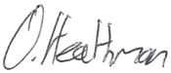
Date: | 17/7/23

