BUILDING LEARNING POWER!
Talking about how we think and how we learn.
RESILIENCE  We keep on keeping on! We keep trying and can manage our distractions. We notice and concentrate and are determined to finish something.  RESILIENCE is one of our school Christian values | RECIPROCITY  We work with others and share our ideas. We listen, we magpie and participate.  We need to be KIND and FRIENDLY as we learn together
REFLECTIVENESS  We are able to step back and to look at our own learning.  We can plan, revise and reflect.  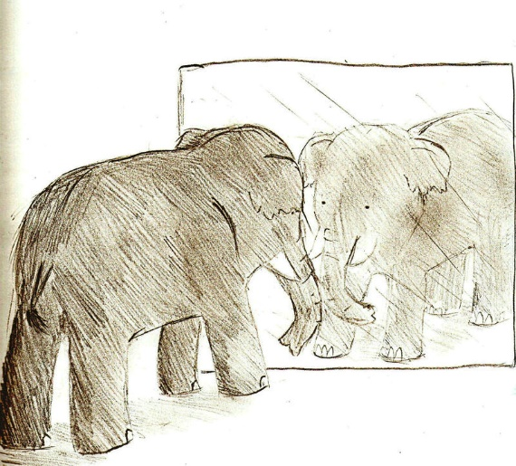  We need to be HONEST  about our own learning | RESOURCEFULNESS  We use questioning, imagination and creativity to link our ideas and to build understanding.  We need to show RESPECT & COMPASSION as we work together

