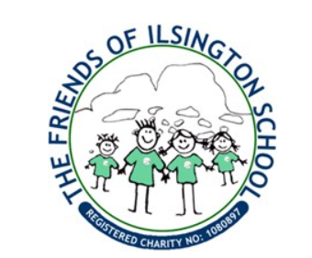
The Friends of Ilsington School is a registered charity, and always busy finding innovative ways to raise funds to donate to school in order to enrich the children’s education and experiences.
Congratulations 🥳 to Forrest for winning the Easter Bunny and Poppy for winning the Peter Rabbit Easter Egg. 🥰 We also gave 4 runners up prizes to Monty, Willow, Martha and Zoe. Thanks to everyone who took part!
Upcoming events:
- 8th May: The Ilsington United Charities, Ilsington Village Hall and Friends are holding a Coronation Cream Tea 3-5pm at the Ilsington Village Hall. All ages welcome - Rose’s playgroup toys will be out.
- 4 Tor sponsored walk (6km) Sunday 14th May: Join us for a sponsored walk starting at 1.30 pm at Hay Tor car park (Manaton Rd) and ending at Great Hound Tor (Rose’s camping barn) for a BYO picnic. Car parking available at Hay Tor, Hound Tor and Great Hound Tor Barn. If you have small kids or accessibility needs – join us just for the BYO picnic at Great Hound Tor Barn. To sign up to this event and for more info on sponsorship and route information email friendsofilsington@gmail.com. Please make sure you sign up to this event to ensure that you receive all event updates (including weather warnings etc.). If you cannot make the sponsored walk but can sponsor others – donate at Just Giving Page – all donations welcome!!!
- Summer Show kids Zone 15th July: 1.30-3.30 pm - are you free to help set up and tidy away and take payment at the entrance for the bouncy castle and soft play area and help sell ice creams? - let us know - only 30 mins of your time needed. Bouncy castle all arranged 😊👍Email: friendsofilsington@gmail.com if you can volunteer some time for this fund-raising event.
Join Us:
The fund-raising group operates with a committee of at least 4 but could be up to 9 members.
We are looking for more parents/carers/family/community members to get involved in the committee. It would be great to have more people with children in Key Stage 2 involved.
If you are interested in finding out more about what this entails, please speak to Sarah Jayne, Amy, Deyna or Bea or email friendsofilsington@gmail.com – we would love to hear from you.

