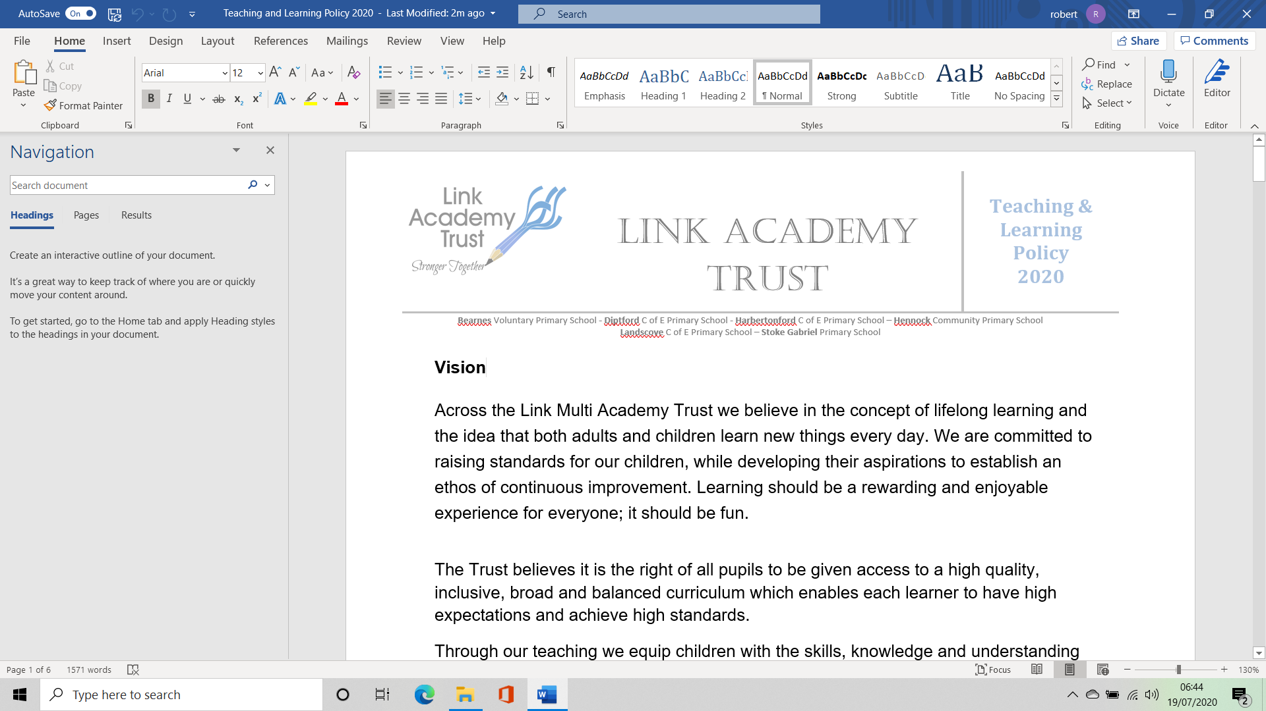

**Ilsington Academy Strategic Improvement Priorities**

**KEY IMPROVEMENT PRIORITIES for 2023-2024**



**Key Priority 1**

**Quality of Education**

.

***Cultural Diversity and understanding modern Britain.***

Improve and increase the opportunities provided to ensure that the curriculum effectively develops pupils’ understanding of all aspects of cultural diversity in the UK.

**Key Priority 3**

***Personal Development***

***Behaviour & Attitudes***

***Metacognition***

To build on previous discussion and research and to embed a metacognitive approach across the school.

**Key Priority 2**

***Personal Development***

***Behaviour & Attitudes***

***Relational Approach***

To further develop and embed research led relational approach across the whole school.

**Key Priority 4**

***Quality of Education***

**Oracy**

To continue to build on last year’s achievements and continue to move towards the majority of children being able to use Tier 2 words as 15% of their text.

**Key Priority 5**

***Personal Development, Behaviour & Attitudes***

**Christian distinctiveness and spiritual development.**

To be able to demonstrate that the children have a good understanding of their own spirituality.